A REPORT ON

#### download.pngGASLEAKAGEDETECTIONSYSTEM SESSION 2023 – 2024

**KUMAUN UNIVERSITY, NAINITAL**

IN THE PARTIAL FULLIFILMENT OF THE REQUIREMENT FOR THE AWARD OF DEGREE OF MASTER OF INFORMATION TECHNOLOGY

DEPARTMENT OF INFORMATION TECHNOLOGY

###### SUBMITTED TO – Mr. VIKRAM BEDI

UNDER THE GUIDANCE OF

###### Mr. ASHUTOSH KUMAR BHATT

SUBMITTED BY – SHEIKH SANA SIGNATURE ROLL NO. – 220120740013

#### DECLARATION

I hereby declare that this project work entitled “**GAS LEAKAGE DETECTOR SYSTEM**”has been prepared by me during the year

2023 -2024 under the guidance of **Mr. Ashutosh Bhatt**and

**Mr. Vikram Bedi** Head of Information technology department, Kumaun University , Nainital in the partial fulfillment of MSc degree prescribed by the college.

I so declare that this project isthe out come of my own effort,that it has not been submitted to any other university for the award of any degree.

NAME–SHEIKH SANA ROLL NO. - 220120740013

ACKNOWLEDGEMENT

I would like to express my pro found gratitude to **Mr.Vikram**

**Bedi**,Head of Information Technology department (Kumaun University)

Fortheir contributions to the completion of my project titled Home Automation System.

I would like to express my special thanks to our mentor **Dr. Ashutosh Kumar Bhatt** for his time and efforts he provided throughout the project. Your useful advice and suggestions were really helpful to me during the project’s completion. Inthis aspect,I am eternally gratefulto you. I would like to acknowledge that this project was completed entirely by me and not by someone else.

Name: signature:

SHEIKH SANA

**ABSTRACT**

Liquefied Petroleum Gas (LPG) is a main source of fuel, especially in urban areas because it is clean compared to firewood and charcoal. Gas leakage is a major problem in the industrial sector, residential premises, etc. Nowadays, home security has become a major issue because of increasing gas leakage. Gas leakage is a source of great anxiety with ateliers, residential areas and vehicles like Compressed Natural Gas (CNG), buses, and cars which are run on gas power. One of the preventive methods to stop accidents associated with the gas leakage is to install a gas leakage detection kit at vulnerable places.The aim of this report is to propose and discuss a design of a gas leakage detection system that can automatically detect, alert and control gas leakage.This proposed system also includes an alerting system for the users.The system is based on a sensor that easily detects a gas leakage. The main purpose of this project is to achieve a successful working prototype that is capable to detect the presence of gas leakage, which in this case, the Liquefied Petroleum Gas (LPG).The devices hould also perform automatic response with the implementation of an alarm system and the essential part of this project is to detect the occurrence of leakage and this is done by comparing the intensity difference of the infrared radiation. Once this condition is true, this will lead to the alarm triggering.

TABLEOFCONTENTS

ABSTRACT

CHAPTER 1 INTRODUCTION 7-17

* 1. Background of Study 7
  2. Problem Statement 7-10
  3. Objectives 10-11
  4. Scope of Study 11-17

CHAPTER 2 LITERATURE REVIEW 18-22

* 1. Infrared Radiation 18
  2. Gas Detection Principle by Infrared Absorption 19-20
  3. Liquefied Petroleum Gas 20-22

CHAPTER 3 METHODOLOGY 23-39

* 1. Procedure Identification 23-24
  2. Illustration of Infrared Gas detection Mode 24-25
  3. Circuit Construction 25
  4. transmitter circuit 25
  5. Receiver circuit 26
  6. Tools and Equipment Required 27-35
  7. Advantage 36-37
  8. Disadvantages 38-39

CHAPTER 4 RESULTS AND DISCUSSION 40-45

* 1. Integrate 41
  2. Infrared Circuit 42
  3. LPG Experiment Result 42
  4. Detecting the Excessive of LPG Leakage 42-43
  5. Advantage of Infrared in Detecting the Combustible Gas..

… 43-44

* 1. Project details 45

CHAPTER 5 CONCLUSION AND RECOMMENDATION 46-51

* 1. Conclusion 47
  2. Recommendation 48
     1. Various gasdetection 48
     2. performance of the circuit 49
  3. Future development 50
  4. Reference 51

# CHAPTER 1 INTRODUCTION

* 1. Backgroundofstudy

Gas detection of a hydrocarbon gas via infrared (IR) absorption requires the absorption of optical energy (IR) by the gas at the wavelength of interest. Different gaseous have different absorption spectrum. In this project, attention will be given to Liquefied oofpropane and butane. Due to the unique absorption properties of gas to infrared radiation, leakage can be detected by measuring and comparing the IR intensity at both source and detector. In order to enhance the effectiveness of the gas leakage detector, a circuit consisting of an alarm system will be implemented to the prototype towarn users when gas leakage occurs.

* 1. Problem Statement

Inmost industries,one ofthe key parts ofanysafety planfor reducing risks to personnel and plant is the use of early

warning devices such as gas detectors. These can help to

provide more time in which to take remedial or protective action.Theycanalsobeusedaspartofatotal,integrated monitoring and safety system for an industrial plant.Rapid expansion of oil and gas industry leads to gas leakage incidents which are very serious and dangerous. Solutions need to be findout at least to minimize the effects of these incidents since gas leaks also produce a significant financial loss. The challenges are not only to design a prototype of the device that can only detect but also automatically respond to it whenever the leakage occurs.Gas leakage poses a significant risk to both residential and industrial environments, potentially leading to fires, explosions,and health hazards. Detecting gas leaks promptly is crucial for preventing accidents and ensuring the safety of individuals and property. In response to this pressing need, the Gas Leakage Detection System with Alarm and Indicator has been developed.The Gas Leakage Detection System integrates advanced sensor technology with alarm and indicator modules to provide a comprehensive solution for gas leak detection.The system employs gas sensor modules capable of detecting a wide range of gases commonly found in domestic and industrial settings, including methane, propane, butane, and carbon monoxide. These sensors continuously monitor the surrounding air for the presence of gases, offering real- time detection capabilities.

Upon detecting a gas leak, the system activates a series of safety measures to alert individuals and mitigate potential risks. A microcontroller processes the signals received from the gas sensors, enabling precise analysis of gas concentration sand quick response to any detected leaks.The microcontroller triggers a 5V relay module, which in turn activates both audible and visual alarms.The audible alarm,in he form of a buzzer,emitsa loud sound to attract attention and alert occupants to the presence of gas. Simultaneously, a red LED indicator lights up, providing a visual cue of the gas leak. This dual-alert system ensures that individuals are promptly notified of any potential hazards, allowing them to take appropriate action to mitigate risk sand evacuate the area if necessary.

The Gas Leakage Detection System offers several advantages over traditional gas detection methods. Its real-time monitoring capabilities enable swift detection of leaks, minimizing the time between the onset of a leak and the initiation of safety measures. Additionally, the integration of audible and visual alarms enhances the effectiveness of the system by catering to individuals with varying sensory capabilities.

Furthermore, the system's modular design allows for easy integration into existing infrastructure, making it suitable for both residential and industrial applications. Whether installed in homes,commercial buildings

,orindustrial

facilities, the Gas Leakage Detection System provides a reliable and cost-effective solution for enhancing safety and preventing gas-related accidents. In summary, the Gas Leakage Detection System with Alarm and Indicator represents a significant advancement in gas leak detection technology. By combining state-of-the-art sensors withalarm andindicator modules, the system offers comprehensive protection against the dangers posed by gas leaks, thereby safeguarding lives andproperty .

* 1. Objectives

The objective of a gas detector sensor is to detect the presence of specific gases in the environment and provide timely warnings or alarms when the gas concentration reaches potentially hazardouslevels. Gas detectors are used in various industries and applications, including industrial settings, laboratories, residential spaces, and commercial buildings, to ensure safety by monitoring for the presenceof gases such as carbon monoxide, methane, hydrogen sulfide, and various combustible gases. The sensors typically work by detecting changes in gas concentration through various mechanisms such as chemical reactions, ionization, or infrared absorption, and then triggering alarms or alerts to notify individuals of potential dangers.

The objectives of gas detector sensors canvary depending on

thespecific application andindustry,butgenerally,theyserve the following purpose

* + 1. Gas Leak Detection:

The primary objective of gas detector sensors is to detect the presence of harmful gases in the environment. These gases could include carbon monoxide(CO),methane(CH4),propane (C3H8), hydrogen sulfide (H2S), etc. Early detection helps prevent potential hazards such as fire, explosions, or health issues due to gas exposure.

Types of Gas Leak Detection:-

* + - * 1.Detection Methods
      * 2.Common Gases Detected
      * 3.Detection Technologies
      * 4.Deployment Considerations
      * 5.Response and Mitigation
    1. Alert Generation:

Gas detector sensors trigger alerts or alarms when gas concentrations exceed safe thresholds.This allows for timely evacuation or intervention to prevent accidents or health risks. In an IoT context, these alerts can be transmitted via various communication channels such as SMS, email, push notifications, or directly to a centralized monitoring system.

Types of alert generation:-

* + - * AlarmTypes
      * AlarmLevels
      * Alert Transmission
      * Customization and Configuration
      * Testing and Maintenance

1.3.3.Remote Monitoring:

IoT-enabledgas detectors facilitate remote monitoring ofgas levels in real-time. This feature is particularly usefull inlarge or inaccessible areas where continuous monitoring is necessary but human presence may be limited or hazardous.

TypesofRemoteMonitoring:-

* Real-Time Data Access
* Centralized Dashboar
* Alert Notifications
* Historical Data Analysis
* Remote Configuration and Diagnostics
* Integration with Building Management Systems (BMS)
  + 1. **Data Logging and Analysis:** Gas detectorsensors collectandlogdataongasconcentrationsovertime.This

data can be analyzed to identifytrends, patterns, and potential sources of gas leaks. Insights derived from this analysis can help in optimizing safety protocols,preventive maintenance, and risk mitigation strategies.

Type of data logging and analysis:-

* + - * Data Logging
      * Continuous Monitoring
      * Event Logging
      * Historical Data Analysis
      * Root Cause Analysis
      * Predictive Maintenance
      * Compliance Reporting
    1. Integration with Building Management Systems (BMS):

Gas detector sensors can be integrated with BMS or other automation systems to enable automatic responses to gas leaks. For example, shutting down gas supplies, activating ventilation systems, or triggering emergency protocol.

Types of building management system

* + - * Centralized Monitoring and Control
      * Automated Response Actions
      * Customized Alarm Handling
      * Data Sharing and Visualization
      * Remote Monitoring and Control
      * Scalability and Inter operability
    1. **Energy Efficiency:**In industrial settings,gas detector sensors can contribute to energy efficiency by optimizing gas usage and minimizing waste. By monitoring gas levels accurately, they help in maintaining optimal combustion conditions and preventing excessive gas consumption.

Types of energy efficiency:-

* + - * Sensor Technolology
      * Power Management
      * Wireless Connectivity
      * Integration with Building Systems
      * Remote Monitoring and Control
      * Life cycle Considerations
    1. **Compliance and Regulatory Requirements:** Gas detector sensors assist organizations in complying with safety regulations and standardsrelated to gas monitoring. Continuous monitoring and documentation of gas levels help in demonstrating adherence to regulatory requirements and ensuring workplace safety.

Types of regulatory Requirements:-

* + - * Occupational Health and Safety Regulations
      * Industry Standards
      * Gas Detection Performance Standards
      * Installation and Maintenance Requirements
      * Documentation and Record-Keeping
      * Training and Competency
      * Periodic Audits and Inspections

**1.3.7 Cost Reduction**: Early detection of gas leak sand efficient management of gas usage can result in cost

Savings for businesses.By preventing accidents,minimizing down time, and optimizing resource utilization, gas detector sensors contribute to overall cost reduction.

Types of cost reduction techniques:-

* Efficient System Design
* Life Cycle Cost Analysis
* Energy Efficiency
* Remote Monitoring and Maintenance
* Preventive Maintenance
* Integration with Building Systems
* Risk Mitigation
  1. Scope of Study

The scope of study for this project are:

* To study on the characteristics of infrared (IR) and Liquefied Petroleum Gas (LPG) : Students need to study on the mechanism of infrared being emitted and absorbed. Since LPG is one of the gases that absorbs IR radiation at certain wavelength, the detection principle can be done by comparing the intensity difference before and after theabsorption of the LPG.
* To understand the working principle of alarm system and design the circuit : Alarm circuit has to be constructed to automatically respond to the

Occurrence of leakage.Several

Conditions need to be considered in order to trigger the alarm.

* To design a working prototype of gas leakage detection equipped with automatic alarm system : A successful working prototype consisting of infrared emitter and sensor, alarm circuit and emergency shutdown valve is expected tofunction very well at the end of this project.
* To construct working circuit for infrared transmitter and detector : Transmitter circuit should be able to transmit infrared radiation at a desired frequency. Appropriate detector circuit need to be find to detect the presence of leakage and trigger the relay circuit.

## CHAPTER2 LITERATURE REVIEW

###### Infrared Radiation

Infrared radiation is electromagnetic radiation of wavelength which is longer than the visible light but shorter than the radio wave. There are many common sources of radiation emitting infrared such as sunlight, tungsten and lasers. Infrared light has range of wavelengths, just like visible light, which has wavelengths ranging from red to violet. Figure 2 shows that IR light lies between the visible and microwave portions of the electromagnetic spectrum. Infrared radiation is typically produced by objects whose temperature is above10°K.

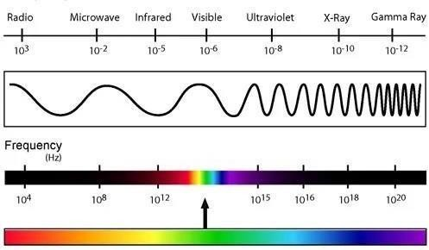

Figure1:Electromagnetic Spectrum

###### Gas Detection Principle by Infrared Absorption

Certain gases in the atmosphere have the property of absorbing infrared radiation. The infrared radiation strikes a molecule such as propane and butane that causes the bonds to bend and vibrate.This is called the absorption of IR energy. The molecule gains kinetic energy by this absorption of IR radiation.

IR radiation does not have enough energy to induce electronic transitions as UV radiation. Absorption of IR is restricted to compounds with small energy differences in the possible vibrational and rotational states.

For a molecule to absorb IR, the vibrations or rotations withina molecule must cause a net change in the dipole moment of the molecule. If the frequency of the radiation matches the vibrational frequency of the molecule then radiationwill be absorbed,causing a change inthe amplitude of molecular vibration . Therefore, the vibrational frequency of the infrared to be matched with the vibrational frequency is around 88THz.

The existing gas leakage detector in the industry is by using the catalyst detector.This new technology provides major

Advantages over the catalyst detector. Some advantages of using infrared gas detectors are:

* + 1. Immunity to contamination and poisoning.
    2. Ability to operate in the absence of oxygen or in enriched oxygen.
    3. Ability to operatein continuous presence of gas.
    4. Can perform more reliably in varying flow conditions.
    5. Even when flooded with gas,will continue to show high reading and sensor will not be damaged.

###### Liquefied Petroleum Gas:

LPG or LP Gas is Liquefied Petroleum Gas.This is a general description of Propane (chemical formula C3H8) and Butane (chemical formula C4H10), either stored separately or together as a mix . LPG is a mixture of hydrocarbon gases which are propane and butane used as a fuel in heating appliances and vehicles . Propane and butane are gaseous at normal temperature and can be liquefied under low pressure to provide easier packing. The name LPG comes from the fact that these gases can be liquefied at normal temperature by application of a moderate pressure increase, or at normal pressure by application of cooling using refrigeration. LPG comes from two sources. It occurs naturally in oil and gas fields

and is separated from the other components during the extraction process from the oil or gas field. LPG is also one of the by-products of the oil refining process.

LPG is used as a fuel for domestic, industrial, horticultural, agricultural, cooking, heating and drying processes. LPG can be used as an automotive fuel or as a propellant for aerosols, in addition to other specialist applications. LPG can also be usedto provide lighting through the use of pressure lanterns. The advantages of LPG gases are as follows:

* + - Because of its relatively few components, it is easy to achieve the correct fuel to air mix ratio that allows the complete combustion of the product. This gives LPG it's clean burning characteristics.
    - Both Propane and Butane are easily liquefied and stored in pressure containers. These properties make the fuel highly portable, and hence,canbeeasilytransported incylinders or tanks to end-users.
    - LPG is a good substitute for petrol in spark ignition engines. Its clean burning properties, in aproperly tuned engine, give reduced

exhaust emissions,and extended lubricant and spark plug life.

* + - As a replacement for aerosol propellants and refrigerants, LPG provides alternatives to fluorocarbons which are known to cause deterioration of the earth's ozone layer.
    - The clean burning properties and portability of LPG provide a substitute for indigenous fuels such as wood, coal, and other organic matter. This provides a solution to deforestation and the reduction of particulate matter in the atmosphere (haze), caused by burning the indigenous fuels.

Some of the characteristics of LPG are:

* Colourless
* Odourless.
* Flammable.
* Heavier than air.
* Approximately half the weight of water.
* Nontoxic but can cause asphy**.**

## CHAPTER–3 METHODOLOGY

###### Procedure Identificaton

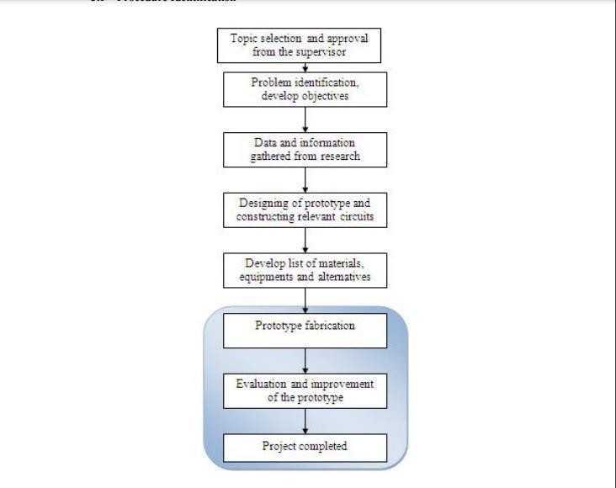

Figure2:Project Methodology

The Figure 2 shows the sequential step by step procedure to befollowed throughout this project. Until now student has reached into the prototype fabrication which is mainly to constructtheinfrared

circuit.Further explanation will be given in the Result and Discussion in the Page no. 40-45.

Illustration of Infrared Gas detection Model

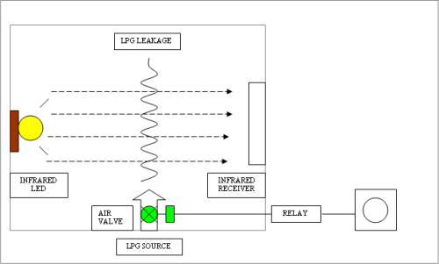

Figure3:Infrared Gas Detection Model

* 1. **It Has (Alarm System):** The first part of this project is to design alarm circuit to be equipped in the prototype. Whenever the presence of gas leakage is detected by the receiver circuit, signals will be sent to the oscilloscope and relaycircuit. The alarm system will automaticallytriggered to warn users of the leakage.

###### Circuit Construction:

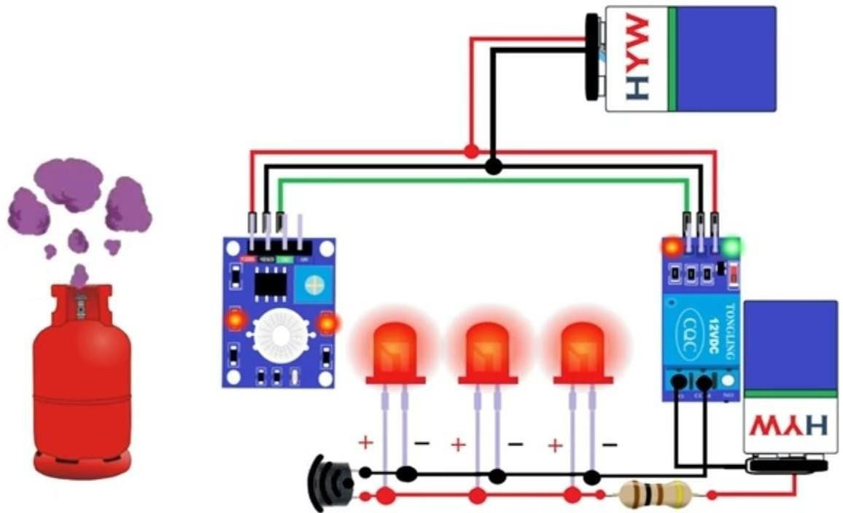

Figure4.Circuitdiagram

###### Transmitter Circuit

Transmitter circuit will be used as the source of IR radiationin this project. Due to the fact that LPG gases absorbs IR at certain wavelength, the transmitter circuit needs to be designedtotransmit desiredIRfrequency.Theory statedthat LPG gases absorb IR radiationat the frequency of 3.4µm .

Frequency = speed of light/ wavelength…

. Equatio

n1

Referring to equation1 :

Frequency=(3.0x10^8)/3.4µm=88THz

###### 3.5.Receiver Circuit

A thermopile detector constructed and arranged to receive infrared radiation after the transmission thereof through the gas samplingregion and to responsively generate an output signal correlative of concentration of at least one selected component of the process gas; and process control means arranged to receive the output of the thermopile detector.

A thermopile detector for a temperature measuring instrument physically and electrically configured to supply an output signal which indicates a target temperature substantially independent of the influence of ambient temperature changes. The detector is comprisedof a plurality of interleaved and electrically opposing thermocouples on a common surface of a substrate wherein the interleaved thermocouples are comprised of active thermocoupleshaving a high emissivity coating to increase the irsensitivity to infrared radiation and blind compensating thermocouples having a low emissivity coating to minimize their sensitivityto infrared radiation.

* 1. **Tools and Equipments Required:**

|  |  |  |
| --- | --- | --- |
| SN |  | Component |
| 1 |  | Gas SensorModule |
| 2 |  | Buzzer |
| 3 |  | Red led |
| 4 |  | LEDBulb |
| 5 |  | Resistor |
| 6 |  | 5V Relay Module |
| 7 |  | Jumper Wire |
| 8 |  | 10 Core Wire |
| 9 |  | Project Cardboard Base |
| 10 |  | Jumper Wire |

## GAS SENSOR MODULE



This is a very easy to use low cost semiconductor LPG sensor Module with analog and digital output. This module uses MQ6 Alcohol sensor as a Alcohol sensing element. It requires no external components justplug in Vcc & ground pins and you are ready to go.

For Digital output the threshold value can be easily set by an on-board potentiometer. Using this module you can easily interface MQ6 Alcohol Sensor to any Microcontroller,ArduinoorevenRaspberryPi.TheMQ-6LPG

* Isobutane – Propane Gas Sensor is a semiconductor gas sensor that detects the presence of LPG Isobutane, and Propane gas at concentrations from 100 ppm to 10,000 ppm, a range suitable for detecting gas leaks. The sensor’s simple analog voltage interface requires only one analog input pin from your microcontroller. The MQ- 6 LPG – Isobutane – Propane Gas Sensor detects the concentration of gas in the air and outputs its reading as an analog voltage. The sensor can operate at temperatures from -10 to 50°C and consumes less than 150 mA at 5V. Tags, MQ-6 LPG & Propane Gas Sensor, MQ-6 GAS Sensor, MQ6 GAS Sensor, MQ-6 LPG Gas Sensor.

Features of MQ6 Alcohol Sensor Module:-

* + High Sensitivity to **Alcohol**, is o-butane, propane
  + Small sensitivity to alcohol, smoke
  + Good sensitivity to Combustible gas in wide range
  + High sensitivity to Propane, Butane, LPG and also response to Natural gas
  + Long life and low cost
  + Simple drive circuit

Applications of MQ6 Gas Sensor Module:-

* + Gas leak detection system
  + Fire/Safety detection system
  + Domestic gas leak age detector
  + Industrial Combustible gas detector
  + Portable gas detector
    1. **Buzzer**–A buzzer is used to alarm the beep sound to indicate and warn the danger to the people working around . The buzzer ia the output of the system . The sound of the buzzer is beep – beep , which indicates the danger .



* + 1. **RED LED–**A Red LED isused to indicate that there is a leak.

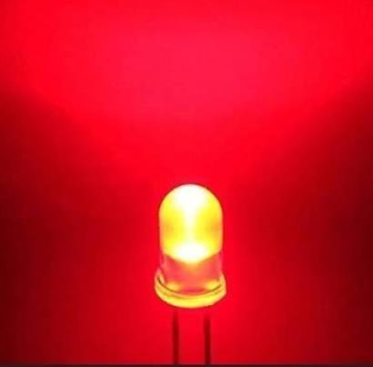

* + 1. **JUMPER WIRE–** A jumper wire is a Small device That can be connected or disconnected to change the setting or configuration of a particular component .



##### 5V Relay Module

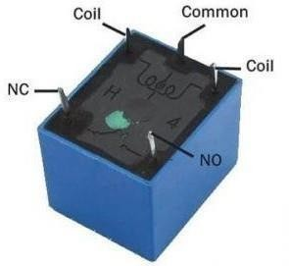

**What is a 5V Relay?**

A 5v relay is anautomatic [switch](https://www.elprocus.com/what-is-a-centrifugal-switch-and-its-working/)that is commonly usedinan automatic control circuit, to control a high-current using a low-current signal. The input voltage of there lay signal

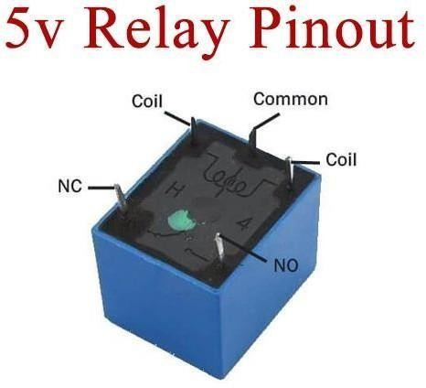

Ranges from 05 V

5V Relay Pin Configuration

The pin configuration of the 5V relay is shown below. This relay includes 5-pins where each pin and its functionality are shown below.

**Pin1 (End 1):** It is used to activate the relay; usually this pin one end is connected to 5Volts.

**Pin2(End2):**This pin isused to activate the Relay.

**Pin3 (Common (COM)):** This pin is connected to the main terminal of the Load to make it active.

**Pin4 (Normally Closed (NC)):** This second terminal of the load is connected to either NC/ NO pins. If this pin is connected to the load then it will be ON before the switch.

**Pin5 (Normally Open (NO)):** If the second terminal of the load is allied to the NO pin, then the load will be turned off before the switch.

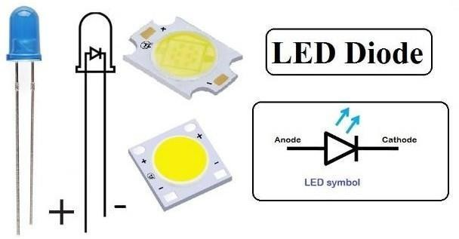

3 V DCLED Bulb We use for showing electricity generating For. whereas another end is connected to the ground.



##### Channel Relay Module One



A relay is an **electromagnetic switch** operated bya relatively small current that can control much larger current. The single-channel relay module comprises of components that make switching and connection easier and act as indicators to show if the module ispowered and if the relay is active or not. It uses an electric current to open or close the contacts of a switch. This is usually done using the help of a coil that attracts the contacts of a switch and pulls them together when activated, and a spring pushes them apart when the coilis not energized.



**Figure - Gas detection leakage system**

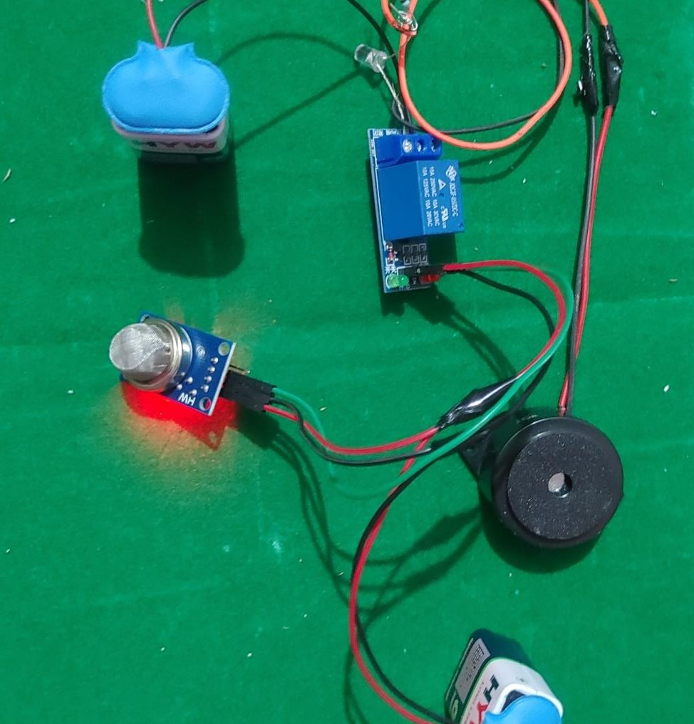

**Figure – Circuit construction Experiment**

#### WORKING PRINCIPLE:

* + - 1. Gas Sensor Detection: The gas sensor module continuouslymonitorstheairforthe presenceofgases. When it detects a gas leak, it sends a signal to the microcontroller indicating the presence of gas.
      2. Microcontroller Control:A microcontroller processes the

signal received from the gas sensor module.Relay Activation: Upon detecting a gasleak, the microcontroller activates the 5V relay module.

* + - 1. Relay Activation:Upon detecting a gas leak,the microcontroller activates the 5V relay module .
      2. Alarm Activation: The relay module, upon activation, triggers the buzzer aLarm to produce an audible alert, signaling the presence of gas.
      3. LED Indicator: Simultaneously ,there lay module also powers the red LED, providing a visual indication of the gas leakage.

3.6.7 Features:

1. Real-time Gas Detection: The system continuously monitors the air for gas leaks, providing real-time detection.
2. Audible and Visual Alerts: The buzzer alarm and red LED provide both audible and visual alerts, ensuring timely notification of gas leaks.
3. Easy Integration: The system components can be easily integratedinto existing infrastructure for enhanced safety measures.
4. Low Power Consumption: The system operates using low-power components, making it energy-efficient.
5. Cost-Effective Solution: The components used in the system are cost-effective, offering an affordable Solution for gas leak detection.

###### Advantages:

1. Enhanced Safety: The project's integration of multiple safety features helps protect homeowners from potential hazards like gas leaks, fires, and intrusions, reducing the risk of accidents andensuring a safe living environment.
2. Real-time Alerts: The system's ability to provide real- time alerts for gas leaks, rain, fire, and intrusions allows homeowners to respond promptly and take necessary precautions .
3. Energy Efficiency: The automatic nighttime illumination feature ensures that energy-efficient LED bulbs are used only when required, contributing to reduced energy consumption.
4. Customizable and User-Friendly: The system can be customized to suit individual preferences and can be controlled through a user-friendly interface or mobile app, offering convenience and ease of use.
5. Peace of Mind:With the comprehensive security and

Automation features, home owners can enjoy peace of mind knowing their property and loved ones are safeguarded, both during the day and at night.

###### Disadvantages:

1. Initial Cost: The installation of advanced sensors and automation components may require an initial investment, which could be considered a disadvantage for some budget-conscious homeowners.
2. Maintenance: Regular maintenance and periodic calibration of sensors and components are essential to ensure the system's continued efficiency and reliability, adding to the ongoing operational costs.
3. False Alarms: The system may occasionally trigger false alarms due to sensor inaccuracies or environmental factors, which could lead to inconvenience and reduced responsiveness over time.
4. Dependency on Power and Connectivity: The system's functionality relies on a stable power supply and network connectivity, making it vulnerable to power outages or network disruptions.
5. Technical Complexity: Building and configuring the system may require technical expertise, and troubleshooting issues might be challenging for users without a technical background.

### CHAPTER4

RESULTS AND DISCUSSION

##### 4.1.Intergrated Infrared Circuit

Since infrared radiation has many advantages whenusedas a gas detector over the catalyst detector, one of the facts that student must know is the infrared source generates heat. The in can descent lamp is inappropriate to use as a gas leakage detector though it is one of the infrared light source sincethis project deals with the detection of combustible gas leakage.

The use of 555 timer circuit also is not suitable as it cannot produce afrequency of TeraHertz - a vibrational frequency desired to match with LPG molecule motion frequency. Therefore, student has replaced the I!C 555 Timer with IC LM741; an operational amplifier to amplifythe frequency generated. The circuit is then being shown as stated in the

Figure below:

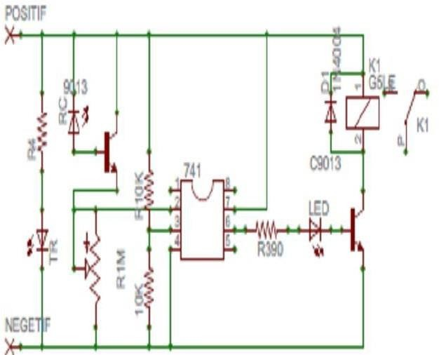

FIGURE4:normal schematic design

##### 4.2LPG Experiment Result

In order to observe the voltage variation of the circuit,adiode and 100ohm Resistor is place at the infrared LED receiver. This is for the purpose of smoothing the voltage and connecting the circuit to the oscilloscope.

The experiment is conducted in the confined area, thus the result is shown below:

Output voltage when there is NO LPG leakage= 8.9VOutput voltage whenthere is an LPG Leakage= 7.8V

The voltage reading is taken from the oscillator. From the graph obtained as shown in Figure the time taken for the circuit to detect the leakage at the distance of 15 cm is 10 second. This is obviously shown when there was a sudden drop in the voltage after the LPG gas was released into the chamber. The voltage began to be at its steady statevalue when the LPG started to disperse in the surrounding which had reduced its concentration.

##### 4.3Detecting the Excessive of LPG Leakage

In order to enhance the level of safety detection, the circuitin Figure 9 has been modified to detect the excess of LPG

leakage. LM 3194n is used to indicate the value of voltage that has dropped based on the absorption of LPG using the infrared radiation. The LM3914 is an integrated circuit that senses analog voltage levels and drives 10 LEDs, providing a linear analog display.

A single pin changes the display from a moving dot to a bargraph.

Current drive to the LEDs is regulated and programmable, eliminating the need for resistors. Figure 15 shows the configuration of IC LM 3914.

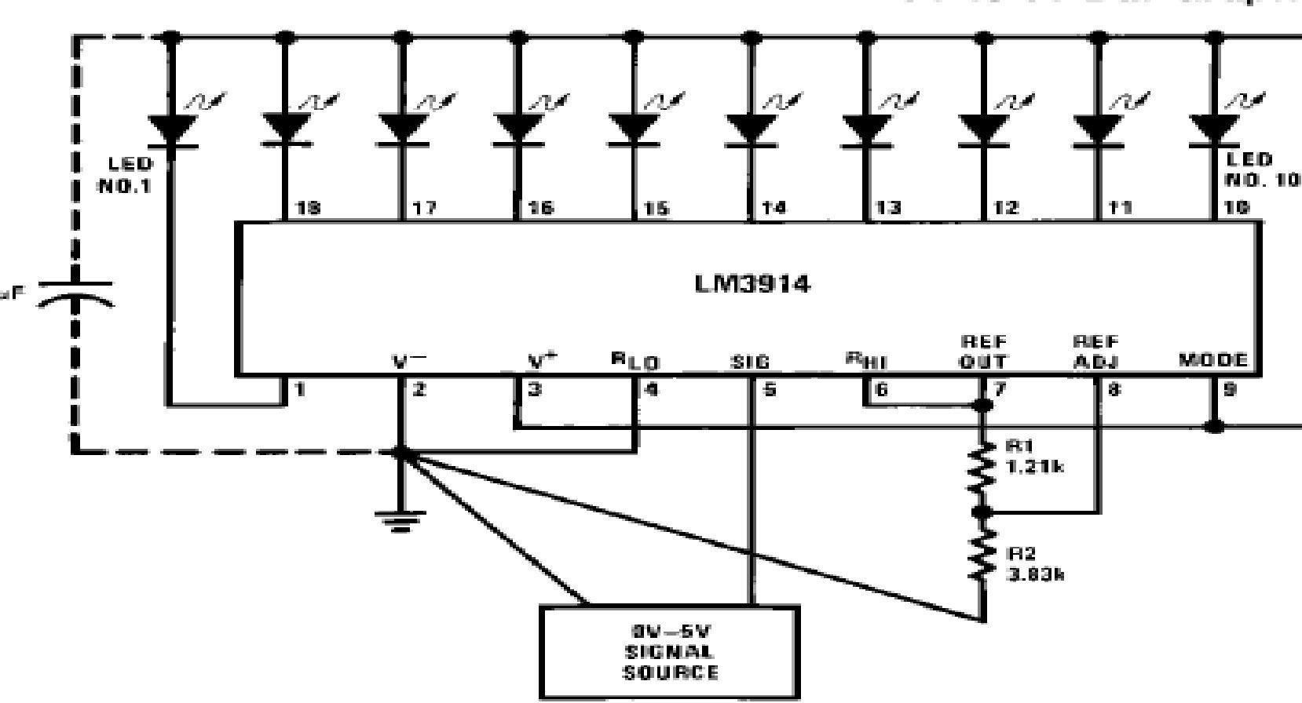

Figure5:LM 3914 configuration

The circuit is then modified and previewe dusing the EAGLE software and the result is 23

###### 4.3Advantage of Infrared in Detecting the Combustible Gas.

Infrared technology is known for high reliability and simple installation. Of the many hydrocarbons that are found in industry today, most are detectable with a catalytic combustion sensor andmany are detectable with an infrared sensor. It is important to consider the specific compounds to be monitored as there are some that do not readily lend themselves to detection with a general purpose infrared (IR) detector, such as hydrogen for example. For better explanation

,we will look at the basic principles of operation for infrared technologies.

The Infrared (IR) detection method is based upon the absorption of infrared radiation at specific wavelengths as it passes through a volume of gas. Typically two infrared light sources and an infrared lightdetector measures the intensity of two different wavelengths, one at the absorption wavelength and one outside the absorption wavelength. If a gas intervenes between

The source and the detector, the level of radiation falling on

The detector is reduced. Gas concentration is determined by comparing the relative values between the two wavelengths.This is a dual beam infrared detector. Infrared gas detection is based upon the ability of some gases to absorb IR radiation. Many hydrocarbons absorb IR at approximately 3.4 micrometers. As mentioned earlier, there are some hydrocarbons and other flammable gases that have poor or no response on a general purpose IR sensor. In additionto aromaticsand acetylene,hydrogen,ammoniaand carbon monoxide also cannot be detected using IR technology with general purpose sensors of 3.4 micron specifications. “The major advantages of IR gas detectors:

Immunity to contamination and poisoning.

Consumables(source and detector)tend to out last catalytic sensors.

Can be calibrated less of tenth an a catalytic detector.Ability to operate in the absence of oxygen or in enriched oxygen.

Ability to operate in continuous presence of gas.Can perform more reliably in varying flow conditions.

Even when flooded with gas,will continue to show high reading and sensor will not be damage.

## Chapter5

### Conclusion And Future development

* 1. **Conclusion:** The Gas Leakage Detection System provides an effective solution for detecting gas leaks and preventing potential hazards. By combining gas sensors with alarm and indicator modules, the system offers reliable detection and timely alerts, enhancing safety in various environments.

In conclusion, the Gas Leakage Detection System with Alarm and Indicat or represents a significant advancementin gas leak detection technology, offering comprehensive protection against the dangers posed by gas leaks in residential, commercial, and industrial environments.

Through the integration of advanced sensor technology with alarm and indicator modules, the system provides early detection of gas leaks,enableings with response and mitigation of potential risks. Real-time monitoring capabilities ensure that gas leaks are detected promptly, minimizing the time between detection and notification.

The system's comprehensive alert system, comprising

audible and visual alarms, ensures that individuals are promptly notified of any potential hazards, regardless oftheir sensory capabilities. This dual alert system enhances safety measures,providing occupants withmultiple means of detecting gas leaks and taking appropriate action.

Furthermore, the Gas Leakage Detection System's modular design allows for easy integration into existing infrastructure, making it suitable for a wide range of applications. Its cost- effective and energy-efficient operation further enhances its appeal, making it accessible to a diverse user base.

Alert system enhances safety measures, providing occupants with multiple means of detecting gas leaks and taking appropriate action.

Furthermore, the Gas Leakage Detection System's modular design allows for easy integration into existing infrastructure, making it suitable for a wide range of applications. Its cost- effective and energy-efficient operation further enhances its appeal, making it accessible to a diverse user base.

Overall, the Gas Leakage Detection System with Alarm and Indicator offers reliable detection and notification capabilities, contributing to the protection of lives and property against the dangers of gas leaks. As technology continues to evolve, it is essential to embrace innovative solutions like this system to ensure the safety and well-being of individuals and communities worldwide.

Top of Form

When designing a combustible gas safety monitoring system for oil and gas petrochemical or other application, a thorough analysis of application’s unique field

environment is needed to ensure optimal performance, safety, reliability and cost effectiveness. A quick decision, of course, can lead to poor detector choices as well as safety, performance, maintenance,and life-cycle cost consequences. As student is doing continuous research on infrared technologies and its application, she believes that

gas detection method using infrared is one of reliable method to be used as a precaution to danger that can be caused by gas leakage. The implementation of automated safety systems such as shutdown valve and alarm system will enhance the effectiveness of this method to users.

The integrated infrared circuit has been constructed and tested until this period of time. Future works that has to be done in this project Is to fabricate the gas chamber as well as combining the alarm circuit into the integrated infrared circuit. The analysis to measure the reliability of the infrared circuitalsohas to be improvised so that this gas detector become immune to any eternal noise and errors.

###### Recommendation

For improvement in the future, some additional featurecould beadded in order to make increase the performance and capability of the circuit. Some recommendations are briefly explained below:

###### Various Gas Detection

This model can only detect various combustible gasses at certain distance. By applying the theory of infrared absorption, gassed like Sulphur, carbon Monoxide, Nitrogen Dioxide and other gasses which are toxic and poisonous can only be detected by infrared at certain

wavelength. The future improvement of this project will helpto improve the functionality of this model.

* + 1. Performance of the circuit

When the LPG has dispersed into the surrounding, its concentration will be decreased.Therefore, this model will not be able to detect the leakage appropriately. The design of this model has to be improved so that it can detect the leakage just as the leakage had occurred.

###### Future development

Effectiveness of this project can be improved by following this Recommendation

We can make high quality IR Sensor system

We will increase the sensor range for perfect controlling

###### Reference

* + 1. Literature Survey of **Luminous, Su-Kam** from google. com
    2. Literature Survey of Md.A.Hussain from google.Com
    3. [https://www.flipkart.com](https://www.flipkart.com/)
    4. [https://www.electronicscomp.com](https://www.electronicscomp.com/)
    5. [www.googleimages.com](http://www.googleimages.com/)
    6. [www.reserchgate.com](http://www.reserchgate.com/)
    7. Various web pages form google for search of Capstone project

Websites :

[https://how2electronics.com/gas-leak-detection-alarm-using-](https://how2electronics.com/gas-leak-detection-alarm-using-mq2-sensor-arduino/) [mq2-sensor-arduino/](https://how2electronics.com/gas-leak-detection-alarm-using-mq2-sensor-arduino/) [https://quartzcomponents.com/blogs/electronics-projects/lpg-](https://quartzcomponents.com/blogs/electronics-projects/lpg-gas-leakage-detector) [gas-leakage-detector](https://quartzcomponents.com/blogs/electronics-projects/lpg-gas-leakage-detector)

Images Reference : <https://images.app.goo.gl/hgviDjM6EdVSpUCQ8> <https://images.app.goo.gl/TKNevd7d571i7pbg8> <https://images.app.goo.gl/omCJLESZZNaFRwF97> <https://images.app.goo.gl/NwdZZ7fhBMNcFFtW6> [https://www.amazon.in/Science-Experiment-Projects-Birthday-](https://www.amazon.in/Science-Experiment-Projects-Birthday-%20%20%20%20%20%20Electricity/dp/B0CB1Z5QSK)

[Electricity/dp/B0CB1Z5QSK](https://www.amazon.in/Science-Experiment-Projects-Birthday-%20%20%20%20%20%20Electricity/dp/B0CB1Z5QSK)

[https://i0.wp.com/colourware.org/wp-](https://i0.wp.com/colourware.org/wp-content/uploads/2013/11/electromagnetic-spectrum.jpg?ssl=1) [content/uploads/2013/11/electromagnetic-spectrum.jpg?ssl=1](https://i0.wp.com/colourware.org/wp-content/uploads/2013/11/electromagnetic-spectrum.jpg?ssl=1)